# THE SPORT OF PIGEON RACING

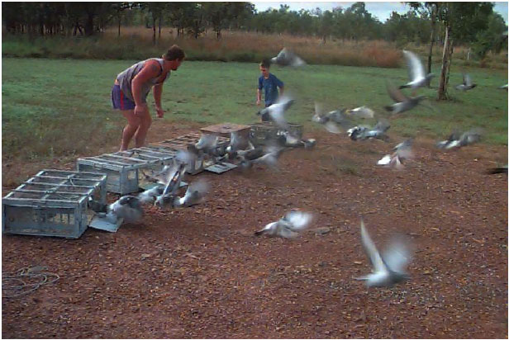

Pigeon racing is an ideal sport for all family members.

Pigeons are easy to look after and develop an attachment with their carers.

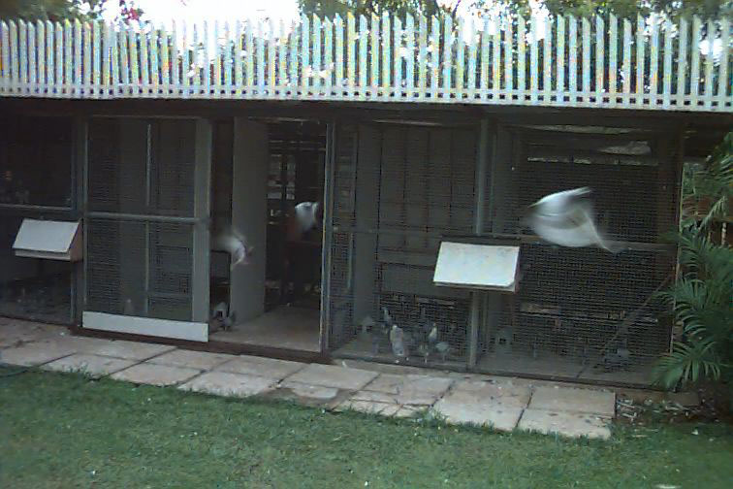This information package was created to try and share this interesting and rewarding pastime with children and adults from all cultural backgrounds.

**THE RACING PIGEON**

The racing pigeon is a specialist pigeon. Bred to fly fast and direct to its home.

Features such as endurance and courage have been encouraged from the very early times.

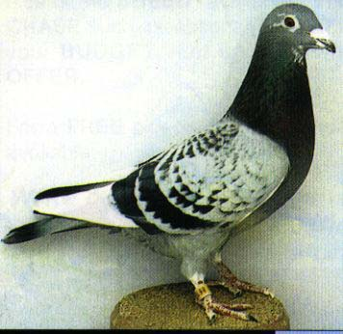

Pigeons have been used for message carrying throughout the history of man.

In times of war racing pigeons have been used to carry urgent messages between troops at the front lines to general headquarters. Several hundreds of soldiers owe their lives to these feathered war heroes. Several have been awarded the Victoria Cross for bravery.

These days, racing is highly competitive and specialised.

Strains have been developed for their speed over distances from 60 to 400 kilometres or for their speed and endurance in races ranging from 400 to 1300 kilometres.

**SELECTION OF STOCK**

1. Try to purchase or procure the best stock available.

2. **Quality** is better than quantity

.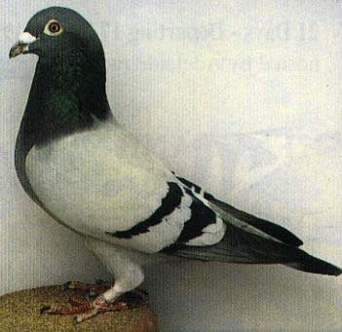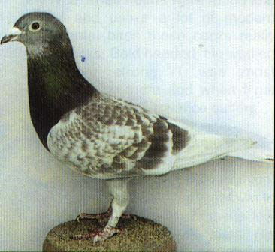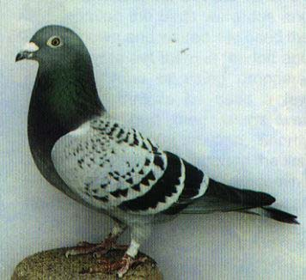

3. Try to get an experienced flier to go with you if you are not confident.

4. Performance and ability to pass on performance must be of the highest importance.

5. Approach an **experienced and successful flier**. They will breed you some from their best if approached the right way and you show that you can be responsible and honest.

6. It is best to get young pigeons and home them. This assists with not losing them accidentally if you haven't homed them and they get out.

**BREEDING**

Pigeons are easy to breed, however this is the hardest area to become proficient in and successful.

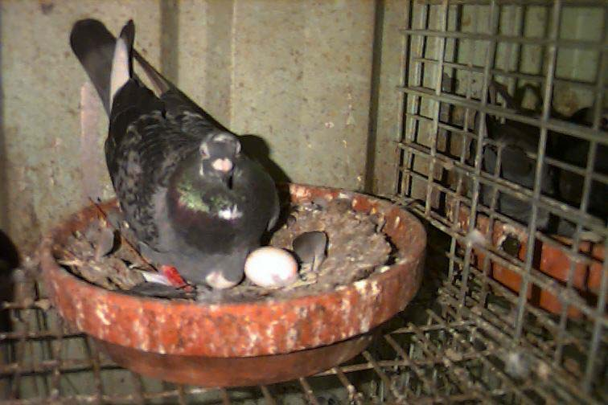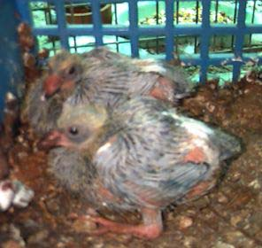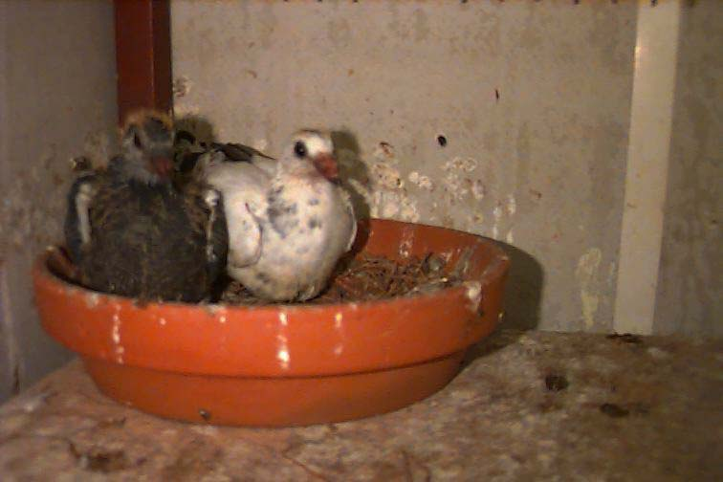

**Main Points**

1. Only breed with the best quality birds available - they must be in excellent condition

2. Try to match the birds so as they are balanced eg similar size, characteristics and purpose

3. Feed a very good quality mix - high in pea content for protein

4. Breeders must have food available all the time

5. Grit and pick stone must be available at all times

6. Vitamins and mineral supplements should be give at least once a week

7. Provide a nest box and bowl with nest material for the breeders.

8. Don't disturb the breeders while they are sitting on eggs.

9. Handle the babies from ringing age (6 days) at least once a day to get them use to you.

10. Wean the babies at 26 to 28 days old.

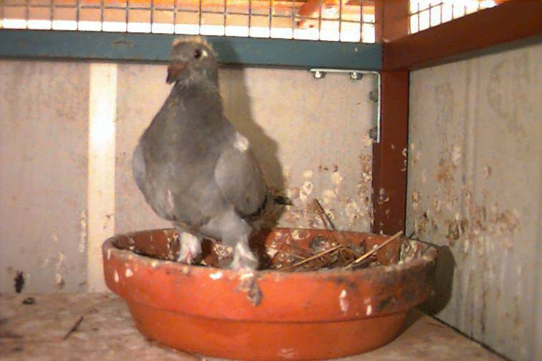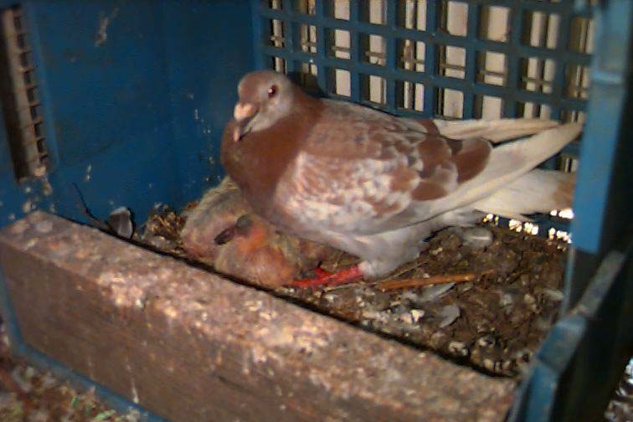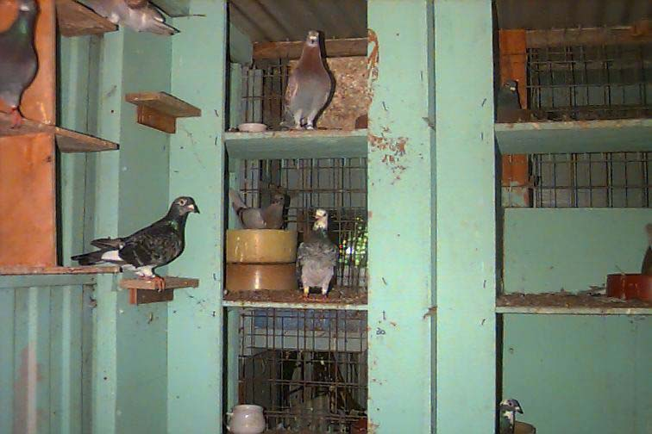

**Feeding**

Feeding is very important. The season changes so does the feed requirements. Here are a few tips.

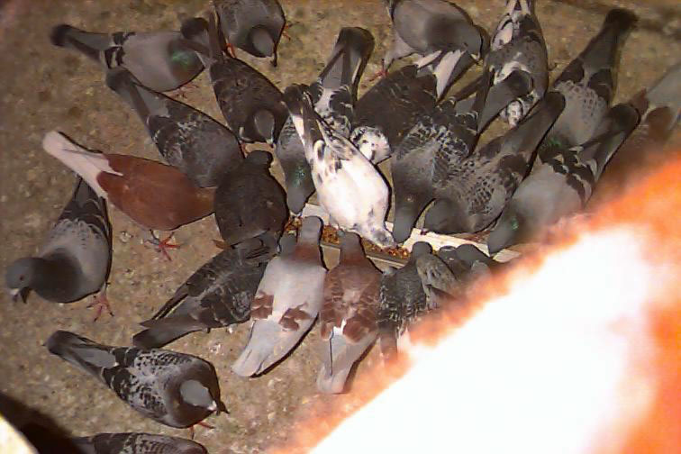

**\* NEVER OVER FEED**

**\* Never let your birds out after they have been fed.**

**\* Fresh water twice a day**

1. Always buy the **best quality** you can.

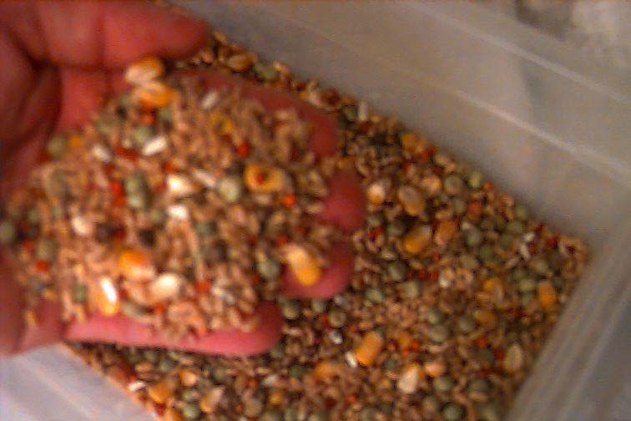2. Buy 2 or three different brands and mix them together. This increases the variety of grain and assures general quality.

3. Breeding - grains need to be high in protein e.g. dun peas, maple peas, vetches

Breeders should always have these grains available all the time they are breeding.

4. Moulting - grains need a high protein e.g. dun peas, maple peas, vetches and oil mix eg linseed, rape, safflower.

5. Racing - grains need to be high in carbohydrate eg maize, milo, wheat and contain some of the grains mentioned above.

6. All these seeds are in a good mix. However they vary in quantity and proportion as the season varies.

7. Grit and minerals should always be available to the birds.

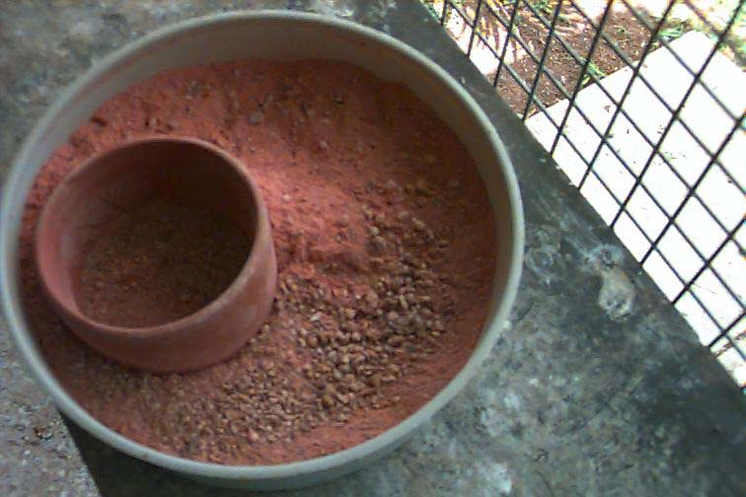

**THE MOULT**

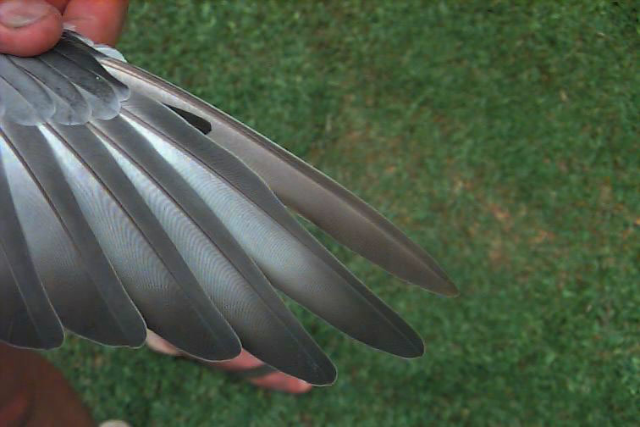Pigeon are constantly loosing and replacing feathers - this is natural and healthy.

The main moult starts to take place at 12 weeks of age and continues if there are no stresses that will inhibit the moult.

1. Fresh water, vitamins, minerals and a rich protein and oil seed diet will assist the moult.

2. Don't force the birds to fly at this time.

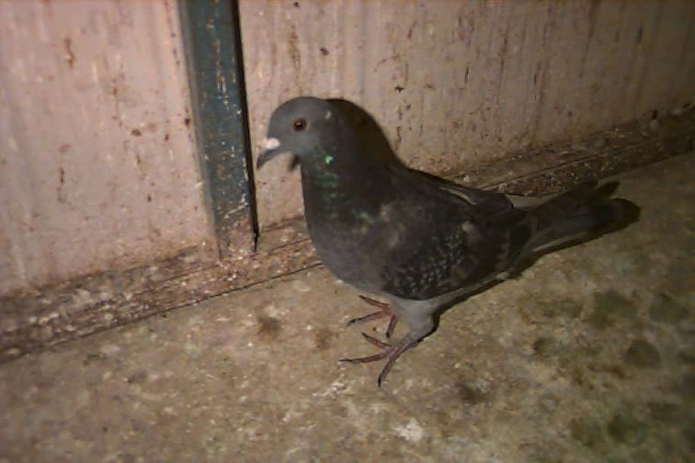3. Loft cleanliness must be very good.

Clean out at least once a day.

**Pigeon Lofts**

A loft can be simple and cheap, as well as being successful.

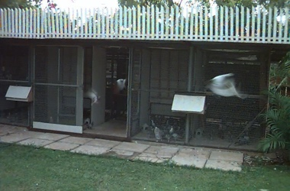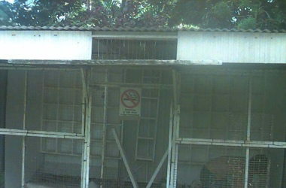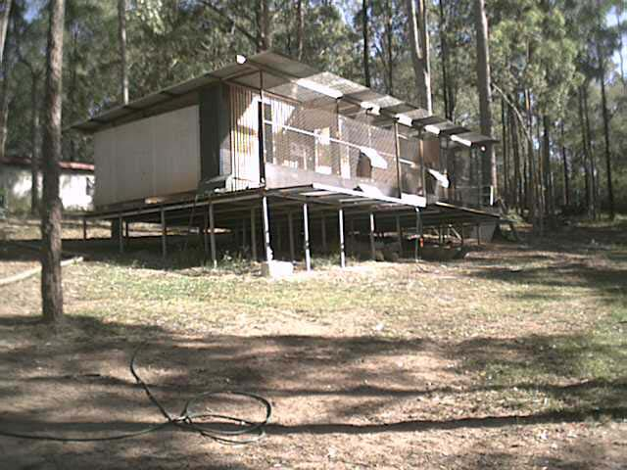

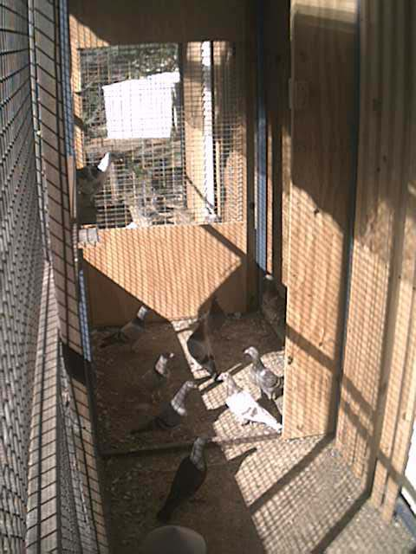**Essential needs**

1. The loft needs to be dry at all times.

2. Well ventilated but not draughty.

3. Vermin free

4. Be divided into sections for ease of management eg. 2 sections for stock birds - cocks and hens and 2 or 3 sections for racing birds.

This enables you to separate the sexes and allow the birds that home to exercise.

5. A trapping device needs to be included in the loft design

6. Visit as many fliers in your area and view their lofts and ask questions. Club members are willing to help new members build a loft.

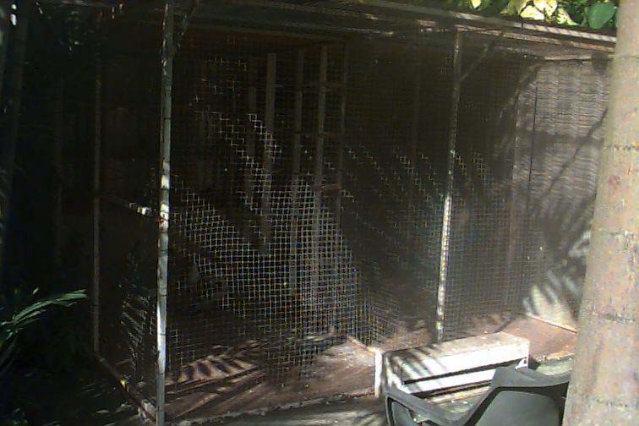**TRAINING YOUNG BIRDS**

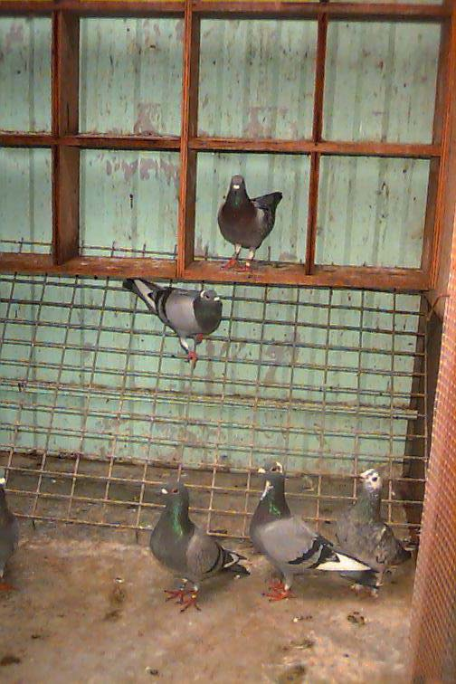

*Young birds needed to be handled at a very young age on a regular basis. (Once a day)

* Feed a good quality mix - protein rich for growth

* Be calm and let the birds get to know you

* Only let birds out before they are fed their meal

* Some fliers use a viewing cage on the landing board or roof - youngsters (4-5 weeks) are placed in the cage to view the surroundings before they are allowed to exercise freely.

* The closer to 4 weeks of age the easier it is to train them to your trap and the outside world as they won't take flight if scared.

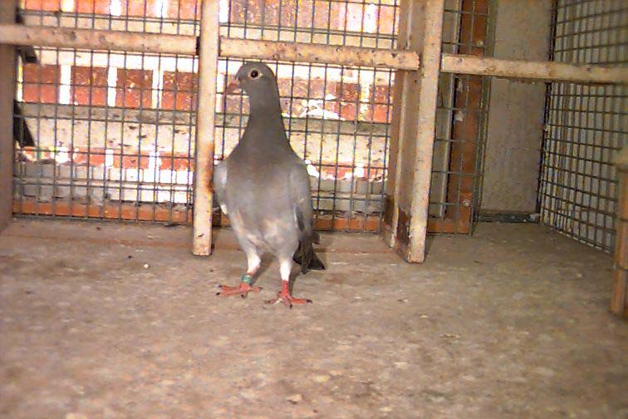

* When it is time to feed the youngsters - call them with a whistle or a rattle of the feed tin. This must be done so they associate the food with you.

* When the birds are ready (6-8 weeks) they should be taking to the air and exercising at least once a day.

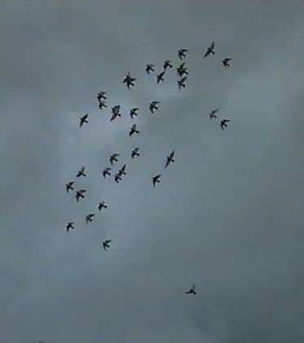* No birds are allowed to land on poles or roofs of houses.

*Exercise once a day is enough until the moult is complete and training for racing begins.

* Bath your birds regularly - 2 times a week

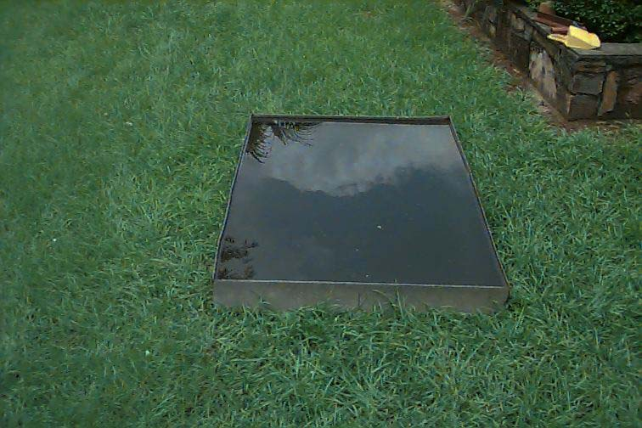* Let them pick food out of your hand

**RACE TRAINING**

When the moult is complete the birds will increase the time they are flying and working around the loft.

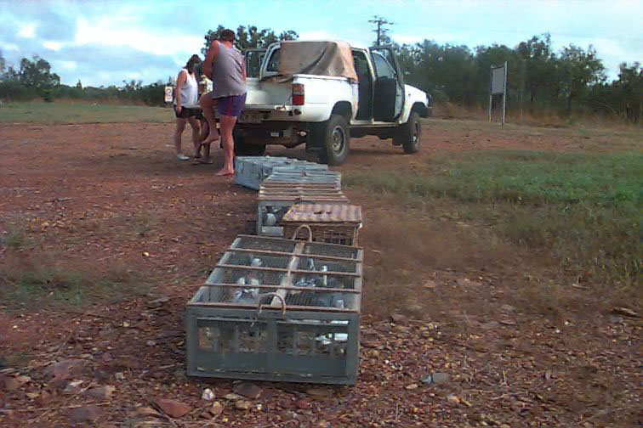

Before racing commences your birds need to be taught to drink and eat in a race basket.

To do this, place 15 -18 birds in a race basket - sit the basket on a table out of predator’s harmful presence.

Leave them a couple of hours and then give them a drink in the troughs provided. Make a fair amount of splash to attract the bird’s attention.

After 5 minutes give them a light feed sprinkled on the floor of the basket.

Let them stay overnight in the basket and let them go first thing in the morning.

When the birds are ranging (flying high and running across the sky and disappearing for periods of time) you can think about tossing.

Tossing the birds commences from approximately 5km and increases in steps.

For example

2x 5 km; 2 x 10 km; 2 x 20km; 2 x 40km; 2 x 80 km 2 x 120 -150 km.

Some fliers adjust the amount of tossing as required. More at shorter distances if the birds are not coming home quickly.

Members often toss together to teach the birds to break and to save petrol money.

**Training Old Birds**



Old birds gradually bring themselves into form by working around the loft soon after the body moult has commenced.

Old birds may work with the young bird team around the loft but don't require as much tossing.

They become very territorial and will fight zealously for their perch or nest box.

Keeping them fit but fresh is the secret.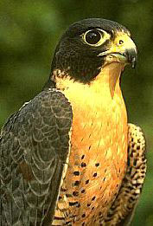**Predators**

Pigeons have a few natural predators.

The peregrine falcon is the most feared as they usually hunt in pairs and can decimate a flock of pigeons in minutes.

For every pigeon it kills as it hunts dozens are hurt trying to escape.

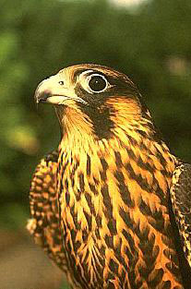

Pigeons often make it home to the loft with deep cuts and damaged wings. In most cases the birds recover but the emotional damage takes a long time to heal.

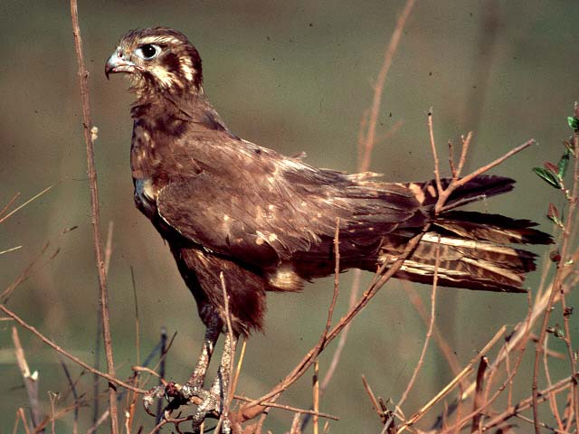Goshawks and swamp harriers are a particular nuisance as they land on the loft wire and will even enter the loft and kill birds.

These menaces frighten the birds to such an extent that it is basically impossible to race the birds.

**Trapping**

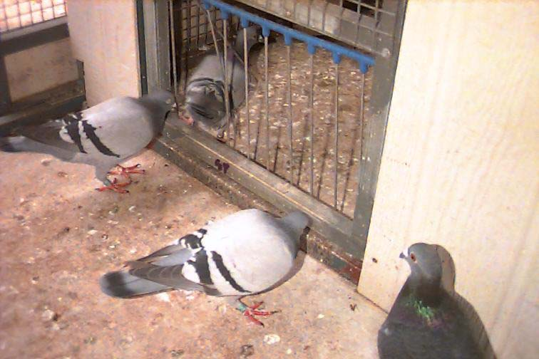

Trapping the birds at the end of a race is one of the most critical parts to racing pigeons.

Pigeons need to trap quickly and be easily caught as races can be won or lost at this time.

Firstly each flier must decide what type of trapping device to use.

1. Open door

2. Open door with a combination of bob wires

3. Bob wires

**Bob Wires**

4. Drop in hole

5. American trap

6. Sputnik

7. Electronic timing

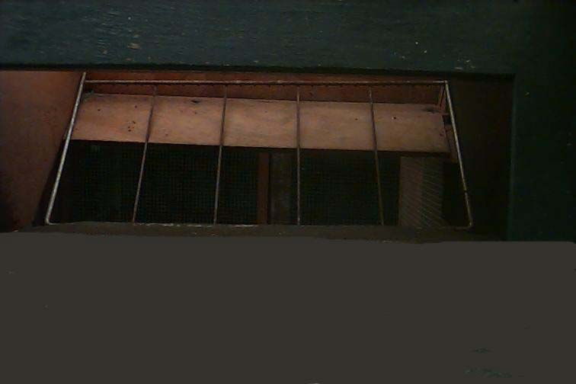

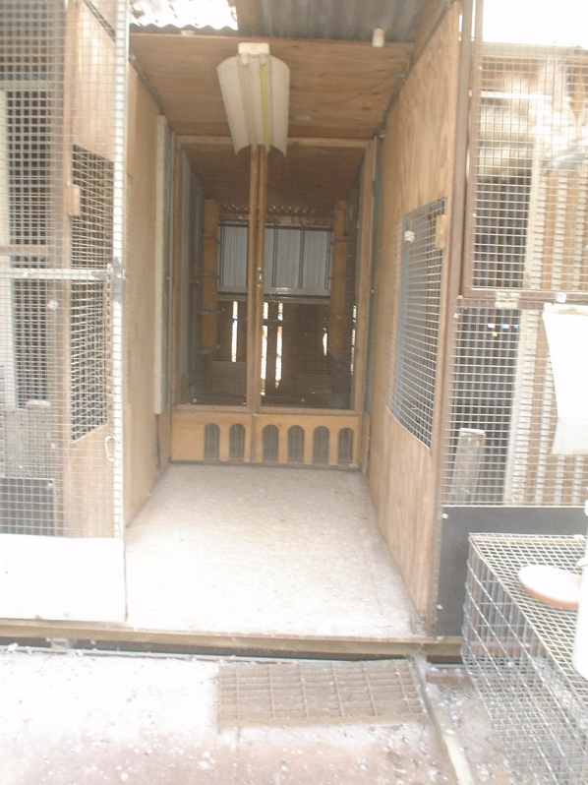

The key to trapping is

1. Peaceful loft

2. Birds use to a particular call and routine

3. Use of a decoy bird

4. Birds must not be grabbed and scared when removing the race rubber.

**Open door & walk through Bob wires**

Drop trap

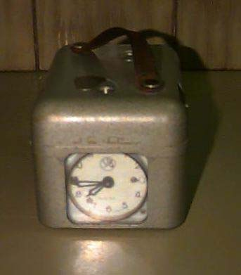**Racing and Clocking**

Only healthy, fit birds capable of winning or being set up for particular races should be entered.

Most fliers try to map a program of races for each pigeon so as to have a few birds in peak race condition continuously throughout the season. (18 - 25) races

A team is picked out on the day of basketing and usually fed a high carbohydrate diet.

The flier observes the birds when exercising, or having a bath or just picking in the yard for signs of fitness.

**Signs**

Enjoy their exercise - tipple and roll - fly solidly for 1/2 to 1 1/2 hrs - flap and flutter and hover just off the ground - look sharp and shiny - chalky white wattle.

White ceres and wattle

Pink throat with small oval shape windpipe

Small, brown droppings with a few down feathers sitting on top where they perch.

When handled are ‘muscley’ but feel buoyant and light.

Breast muscle pink, clear skin – no scale

Clean the bird’s feet and place in your basket to take to the club for the race.

You will have to fill out an entry form in your race book.

Race night basketing - see next chapter.

When the birds return from a race, call them the same as every other day. Have the clock in the same familiar place. Food and water (containing glucose or honey) must be available.

Don't grab at the returning bird - pick it up calmly and remove the race rubber and place it in the clock.

**Race Basketing Night**

On race basketing night there are a number of tasks being performed.

1. The clock setters set the clocks and seal them. They will be struck off against the master clock at 8.00 pm and again on the Sunday clock off at 4.00 pm. This is when the clocks are read and the velocity is worked out to decide who wins.

Basically it is the **distance** *divided* by the **flying time in minutes**.

2. The race marking of the birds is done with a race rubber placed on the bird’s leg and the secret number recorded on the nomination form.

3. The race baskets are sealed and water is placed in the drinkers.

4. The birds are transported to the race point by Club members and contract road transport.

**Health and Medication**

Health is a priority and to gain health and fitness the birds must be looked after 365 days of the year.

Tips

1. clean out at least once a day
2. fresh water 2 times a day
3. good quality feed - don't over feed - approx 1 ounce or 30 gms per bird per day
4. only medicate or treat birds for known problems
5. ask experienced fliers to help with diagnosis
6. bath pigeons regularly
7. books such as Dr Colin Walker's Health books are freely available

**Clubs**

Our club meets regularly throughout the racing season and a few times during the off and breeding seasons.

Clubs rely on everybody to contribute in some way. Remember if every one helps, we all only have to do a little.

Most members are willing to help new members and each other. Be honest and up front when dealing with fliers and assistance will be forthcoming.